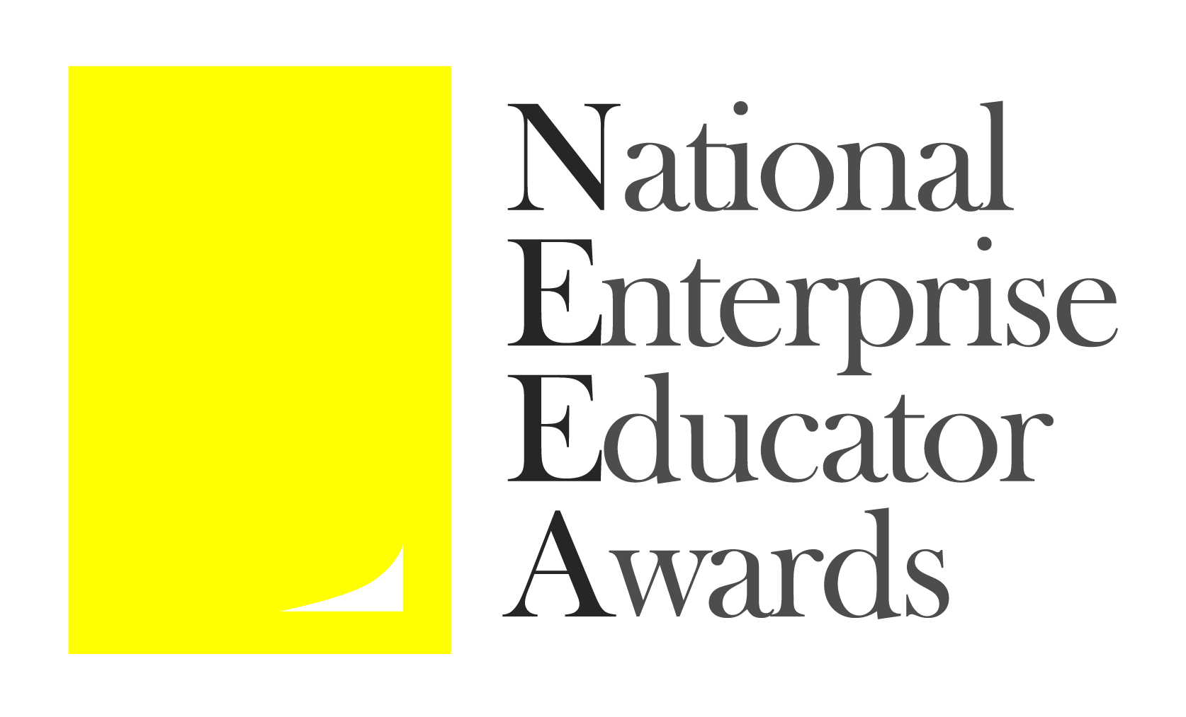

National Enterprise Educator Awards 2022

‘Rising Star in Enterprise Education’ Nomination Form

Submission Deadline – Midnight, Wednesday June 1st 2022

Please read the Terms and Conditions and Judging Criteria before completing this form.

Application process
The person nominating the applicant should complete the application form below, and return to lynn@enterprise.ac.uk by the submission deadline (see date above).
The nominator will receive an email confirming receipt of the submission within one working week. If this is not received please contact:
Lynn O’Byrne, email: lynn@enterprise.ac.uk, mobile 07973 458208
The nominator and nominee will be informed of the judges’ decision regarding shortlisting in early July.
All communication regarding the application will be made with the nominator up to the point of shortlisting. After that we will communicate with both nominator and nominee.

Award sponsors

SimVenture Business Simulations

Varsity Ventures

Award organiser
The National Enterprise Educator Awards are organised by Enterprise Educators UK.
Enterprise Educators UK would like to thank the sponsors for their generous support.
www.neea.org.uk

Application Form

Nominator and nominee details
Nominator
Title: | First name: | Last name:
Institution: | Job title:
Email: | Telephone:
Context in which you know or work with the nominee:

Nominee
Title: | First name: | Last name:
Institution (if different from above): | Job title:
Email: | Telephone:

The nominator should inform the nominee that they have been nominated.

Award category
What is a “Rising Star in Enterprise Education”
This award is designed to recognise an exceptional individual at the early stage of their enterprise or entrepreneurship education / practice career. They should have been working in enterprise for three years or less and may be working inside or outside the curriculum in higher or further education. The judges are particularly keen to recognise individuals who are already making an exceptional contribution while demonstrating their potential for transformational future impact on their organisation’s development and delivery of enterprise and entrepreneurship education and support. The entrant must be employed by a UK higher or further education institution. A ‘Rising Star’ will be nominated by a colleague or a senior manager.

Details of the nominee’s enterprise education work or activities
Background and context to the enterprise education work / activities that support this application. (This section provides important context for the judges but is not allocated any marks):
(300 words maximum)

What is the individual’s role within enterprise/entrepreneurship education and what are the key examples of best practice? (25% of judges’ marks):

(300 words max)

What has been the individual’s biggest achievement(s) since starting their career in enterprise/entrepreneurship education? (25% of judges’ marks):

(300 words maximum)

What evidence is there of the impact the individual has had within their organisation in relation to enterprise/entrepreneurship education? (25% of judges’ marks):

(300 words maximum)

Why do you believe this individual has the potential to deliver transformational impact within enterprise and entrepreneurship education in the future? (25% of judges’ marks):

(300 words maximum)

Through your work, how are you driving change in Equality, Diversity and Inclusivity (EDI) in the areas of enterprise and entrepreneurship education and practice (your entire entry together with this response will be assessed for the Inclusive Enterprise Education award):

(300 words maximum)

Please provide a summary of the entry to be used in the NEEA awards programme and on the website if the entry is short listed.
This information must be supplied but will not be used by the judges.
(100 words maximum)

Declaration by the person making the nomination
I have read, understood and agree to comply with the terms and conditions on the NEEA website.
YES NO

