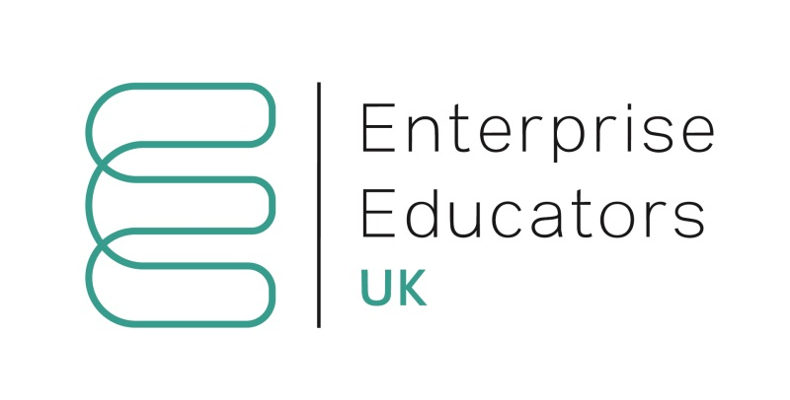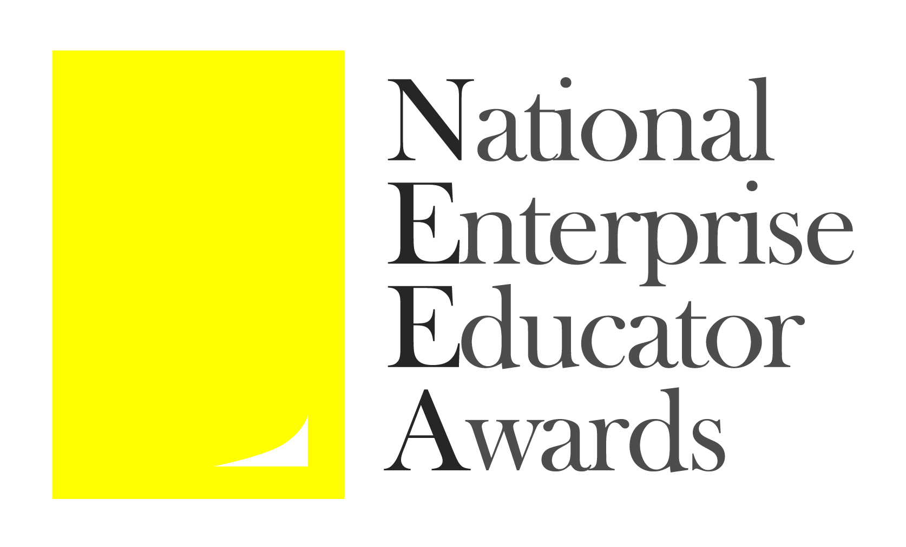

National Enterprise Educator Awards 2022

Enterprise Catalyst

Submission Deadline – Midnight, Wednesday June 1st 2022

Please read the Terms and Conditions and Judging Criteria before completing this form.

Application process
Complete the application form below, and return to lynn@enterprise.ac.uk by the submission deadline (see date above).
You will receive an email confirming receipt of your submission within one working week. If you do not receive this or would like further information, please contact:
Lynn O’Byrne, email: lynn@enterprise.ac.uk, mobile 07973 458208
You will be informed whether you have been shortlisted by mid-July.
All communication regarding your application will be made with the lead applicant who should ensure that relevant information is forwarded to other applicants.

Award sponsors

SimVenture Business Simulations

Varsity Ventures

Award organiser
The National Enterprise Educator Awards are organised by Enterprise Educators UK.
Enterprise Educators UK would like to thank the sponsors for their generous support.
www.neea.org.uk

Application Form

Applicant(s)
Lead applicant
Title: | First name: | Last name:
Applicant’s institution: | Applicant’s job title:
Email | Telephone | Mobile:
Postal address (please provide either home or institutional address)

Other team members
Title: | First name: | Last name:
Institution (if different from above): | Job title:
Title: | First name: | Last name:
Institution (if different from above: | Job title:
Title: | First name: | Last name:
Institution (if different from above: | Job title:
Title: | First name: | Last name:
Institution (if different from above: | Job title:
If more than five team members please add additional rows to the table here.

Award category
What is an “Enterprise Catalyst”?
Open to HE or FE staff working individually or as a team to deliver exceptional enterprise education or practice inside or outside the curriculum. The focus of this award is on developing broad enterprise skills and attributes to be applied in any context including employment and intrepreneurship. An individual or team may enter. Teams must comprise two or more individuals who work together (or have worked together in the last 12 months) on a distinct enterprise education or practice initiative. The individual or team may work within the curriculum, outside the curriculum or both. The judges will be looking for exceptional projects and initiatives that support individuals to develop broad enterprise skills and attributes for their future lives. All team members must be employed by one or more UK higher or further education institutions. Applicants will self-nominate.

Details of your enterprise education work or activities
Title of your application:

Background and context to the enterprise education work / activities that support your application including overall aims and objectives (This section provides important context for the judges but is not allocated any marks):
(300 words maximum)

How were /are your enterprise education work / activities delivered? Include an explanation of why you consider this to be good practice (25% of judges’ marks):

(300 words max)

What do you consider to be the innovative and/or novel aspects of your enterprise education work / activities? (25% of judges’ marks):

(300 words maximum)

How has the work / activities been evaluated? What evidence do you have of the impact and the difference it has made in supporting the development of enterprising skills and attributes? (25% of judges’ marks):

(300 words maximum)

What plans do you have to develop your enterprise education work / activities and how would the prize money be used to support this? (25% of judges’ marks):

(300 words maximum)

Through your work, how are you driving change in Equality, Diversity and Inclusivity (EDI) in the areas of enterprise and entrepreneurship education and practice (your entire entry together with this response will be assessed for the Inclusive Enterprise Education award):

(300 words maximum)

Please provide a summary of your entry to be used in the NEEA awards programme and on the website if your entry is short listed.
This information must be supplied but will not be used by the judges.
(100 words maximum)

Declaration
I/we have read, understood and agree to comply with the terms and conditions on the NEEA website.
YES

NO

