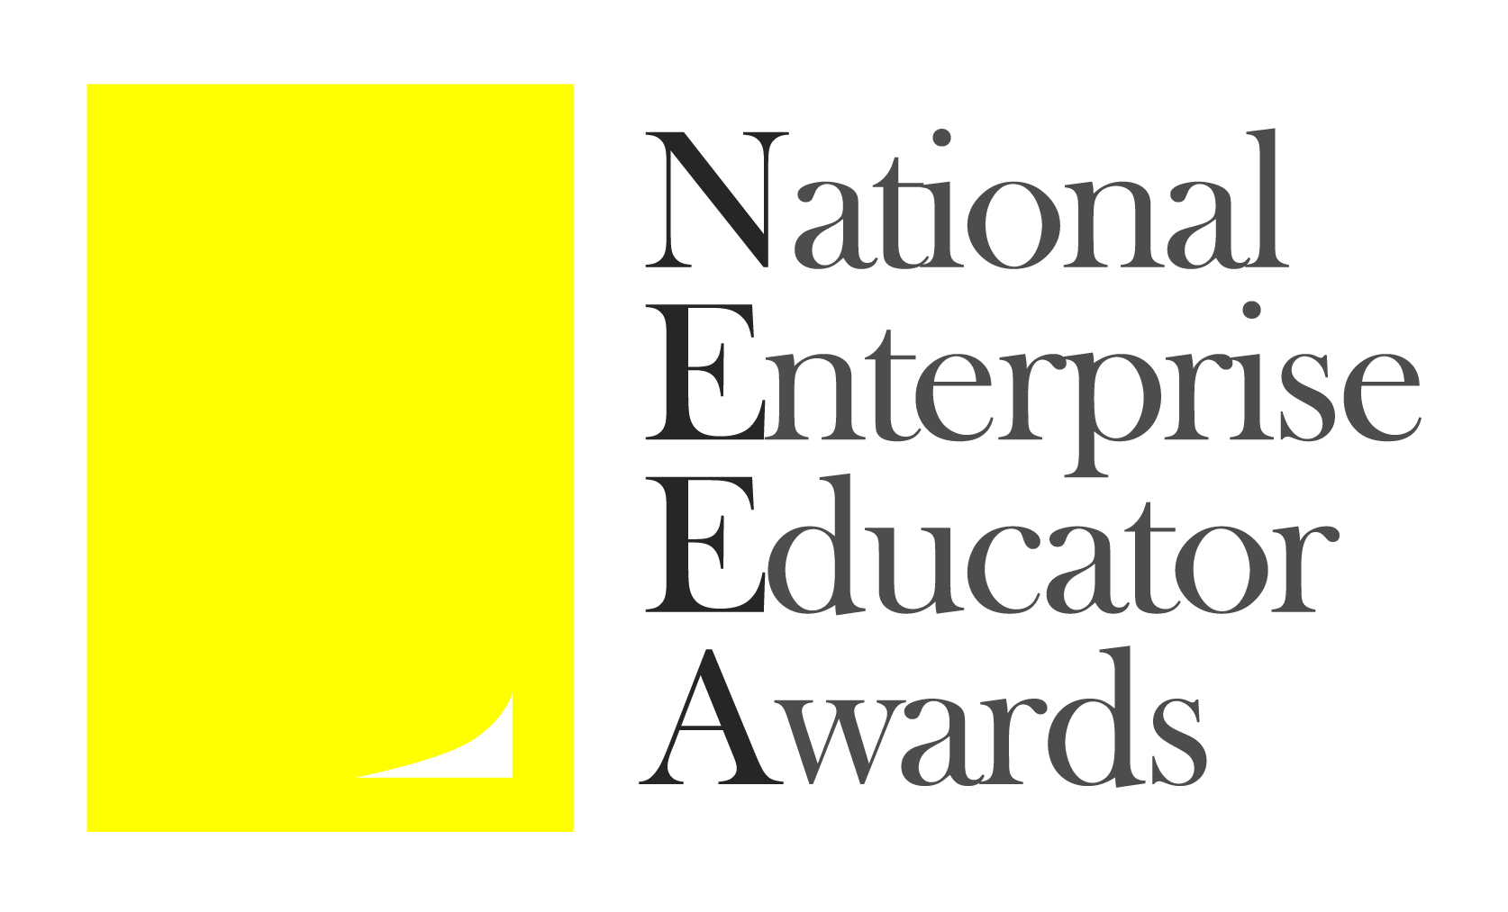

National Enterprise Educator Awards 2017

Application Form

Submission Deadline – Midnight, Friday May 26th 2017

Please read the Terms and Conditions and Judging Criteria before completing this form.

Application process
Complete the application form below, and return to lynn@enterprise.ac.uk by the submission deadline (see date above).
You will receive an email confirming receipt of your submission within one working week. If you do not receive this or would like further information, please contact:
Lynn O’Byrne, email: lynn@enterprise.ac.uk, mobile 07973 458208
You will be informed of the judges’ decision towards the end of June.
All communication regarding your application will be made with the lead applicant who should ensure that relevant information is forwarded to other applicants.

Award organisers
The National Enterprise Educator Awards are organised by NCEE and EEUK.

Award sponsors
SimVenture Business Simulations
CobWeb
Simply Do Ideas

Application Form

Applicant(s)
Lead applicant
Title: | First name: | Last name:
Applicant’s institution: | Applicant’s job title:
Email | Telephone | Mobile:
Postal address (please provide either home or institutional address)

Other team members
Title: | First name: | Last name:
Institution (if different from above): | Job title:
Title: | First name: | Last name:
Institution (if different from above: | Job title:
Title: | First name: | Last name:
Institution (if different from above: | Job title:
Title: | First name: | Last name:
Institution (if different from above: | Job title:
If more than five team members please add additional rows to the table here.

Award category
What is a “Team Enterprise”?
A team of HE or FE staff delivering exceptional enterprise or entrepreneurship education inside or outside the curriculum.
There are two awards – one for those working in higher education and one for those in further education. The team must comprise two or more individuals who work together (or have worked together in the last 12 months) on a distinct enterprise or entrepreneurship initiative or project. The team may work within the curriculum, outside the curriculum or both. The judges will be looking for exceptional teams delivering exceptional initiatives or projects. Those initiatives / projects should support individuals to develop the capabilities they need for an entrepreneurial future. All team members must be employed by one or more UK higher or further education institutions. Teams may self-nominate or be nominated by a colleague or manager.

Please indicate which category you are entering.
HE Team Enterprise

FE Team Enterprise

Details of your enterprise education work or activities
Title of your application:

Background and context to the enterprise education work / activities that support your application including overall aims and objectives (This section provides important context for the judges but is not allocated any marks):
(200 words maximum)

How were /are your enterprise education work / activities delivered? Include an explanation of why you consider this to be good practice (25% of Judges’ marks):
(200 words max)
What do you consider to be the innovative and/or novel aspects of your enterprise education work / activities? (25% of Judges’ marks):
(200 words maximum)

How has the work / activities been evaluated? What evidence do you have of the impact and the difference it has made? (25% of Judges’ marks):
(200 words maximum)

What plans do you have to develop your enterprise education work / activities and how would the prize money be used to support this? (25% of Judges’ marks):
(100 words maximum)

Please provide a summary of your entry to be used in the NEEA awards programme and on the website if your entry is short listed.
This information must be supplied but will not be used by the judges.
(80 words maximum)

Payment details
If your entry is successful, the prize money will be paid by cheque, please specify who this should be made payable to.

Declaration
I/we have read, understood and agree to comply with the terms and conditions on the NEEA website.
YES

NO

